TEST FILE Word.java
 | Test Description | Expected  Result | Actual  Result
1 | Word myWord = new Word("Dave", 2);  Word thisWord = new Word ("Shamus", 5);  // Creates two instances of a Word object using the one present constructor
2 | As (1) but additional  System.out.println("\t" +myWord.getWord() + "\t" + myWord.getFreq()); | Dave 2 | As Expected
3 | As (1) but additional  System.out.println("\t" + thisWord.getWord() + "\t" + thisWord.getFreq()); | Shamus 5 | As Expected
4 | As (1) but additional  myWord.setWord("Jesus");  myWord.setFreq(9);  thisWord.setWord("Maguire");  thisWord.setFreq(8);
5 | System.out.println("\t" + myWord.getWord() + "\t" + myWord.getFreq());  System.out.println("\t" + thisWord.getWord() + "\t" + thisWord.getFreq()); | Jesus 9  Maguire 8 | As  Expected
6 | System.out.println("\t" + myWord.compareTo(thisWord)); | 1 | As Expected
7 | myWord.setFreq(2);  System.out.println("\t" + myWord.compareTo(thisWord)); | -1 | As Expected
8 | myWord.setFreq(8);  System.out.println("\t" + myWord.compareTo(thisWord)); | 0 | As Expected

TEST FILE WordBook.java
 | Test Description | Expected  Result | Actual  Result
1 | WordBook myWordBook = new WordBook();

Contents of AlphaCount4.txt

The nice piece of cheese of piece niece the happening

2 | As (1) but additional:  myWordBook.load("AlphaCount4.txt");  Word w0, w1;  int i = 0;  int j = 1;  w0 = (Word)myWordBook.getWordList().get(i);  w1 = (Word)myWordBook.getWordList().get(j);  System.out.println(w0.getWord() + "\t\t" + w0.getFreq()); // point1  System.out.println(w1.getWord() + "\t\t" + w1.getFreq()); // point2 | // point1  the 1  // point2  nice 1 | As Expected
Notice the word “the” is in lower case; this is because the load method converts each String to lower case before storing them as part of a Word object.

Contents of DaveCount.txt

<>David!£Robert$%^&*()_+-=Uxbridge-Clarke¬`|there's_?:;'#no%buts

3 | As (1) but additional:  myWordBook.load("DaveCount.txt");  Word w0, w1, w2, w3;  int i = 1;  int j = 2;  int k = 3;  int l = 4;  w0 = (Word)myWordBook.getWordList().get(i);  w1 = (Word)myWordBook.getWordList().get(j);  w2 = (Word)myWordBook.getWordList().get(k);  w3 = (Word)myWordBook.getWordList().get(l);
4 | As (3) but additional:  System.out.println(w0.getWord() + "\t\t" + w0.getFreq()); // point1  System.out.println(w1.getWord() + "\t\t" + w1.getFreq()); // point2  System.out.println(w2.getWord() + "\t\t" +  w2.getFreq()); // point3  System.out.println(w3.getWord() + "\t\t" + w3.getFreq()); // point4 | // point1  robert 1  // point2  - 1  // point3  uxbridge-clarke 1  // point4  there’s 1 | As Expected
5 | As (3) but additional:  myWordBook().getWordList().remove(i);  System.out.println(w0.getWord() + "\t\t" + w0.getFreq()); // point1  System.out.println(w1.getWord() + "\t\t" + w1.getFreq()); // point2  System.out.println(w2.getWord() + "\t\t" +  w2.getFreq()); // point3  System.out.println(w3.getWord() + "\t\t" + w3.getFreq()); // point4 | // point1  - 1  // point2  uxbridge-clarke 1  // point3  there’s 1  // point4  ‘ 1 | As Expected
6 | As (1) but additional:  WordBook myWordBook = new WordBook();  myWordBook.load("AlphaCount4.txt");  myWordBook.alphaSort();  Word w0, w1, w2, w3;  int i = 0;  int j = 1;  int k = 2;  int l = 3;  w0 = (Word)myWordBook.getWordList().get(i);  w1 = (Word)myWordBook.getWordList().get(j);  w2 = (Word)myWordBook.getWordList().get(k);  w3 = (Word)myWordBook.getWordList().get(l);  System.out.println(w0.getWord() + "\t\t" + w0.getFreq()); // point1  System.out.println(w1.getWord() + "\t\t" + w1.getFreq()); // point2  System.out.println(w2.getWord() + "\t\t" + w2.getFreq()); // point3  System.out.println(w3.getWord() + "\t\t" + w3.getFreq()); // point4 | // point1  cheese 1  // point2  happening 1  // point3  nice 1  // point4  niece 1 | // point1  1  // point2  cheese 1  // point3  happening 1  // point4  nice 1
An error has occurred; the first entry is 0 characters long. A zero length character should not be included in the results. There’s something wrong with the load method.
7 | Fixed problem in (6), a conditional statement was at fault. | As (6) | As Expected
8 | As (6) but input file = “DaveCount.txt” | // point1  ‘ 1  // point2  - 1  // point3  buts 1  // point4  david 1 | As Expected
9 | As (1) but additional:  myWordBook.load("DaveCount.txt");  myWordBook.alphaSort();  myWordBook.countNRemove();  // Print out results to the command line  for (int i=0; i < myWordBook.getWordList().size(); i++)  {  Word w;  w = (Word)myWordBook.getWordList().get(i);  System.out.println(w.getWord() + "\t\t" + w.getFreq());  } | ' 1  - 1  buts 1  david 1  no 1  robert 1  there's 1  uxbridge-clarke 1 | As Expected
10 | As (9) but input file = “AlphaCount4.txt” | cheese 1  happening 1  nice 1  niece 1  of 2  piece 2  the 2 | As Expected
11 | As (1) but additional:  myWordBook.load("AlphaCount4.txt");  myWordBook.alphaSort();  myWordBook.countNRemove();  myWordBook.descend();  // Print out results to the command line  for (int i=0; i < myWordBook.getWordList().size(); i++)  {  Word w;  w = (Word)myWordBook.getWordList().get(i);  System.out.println(w.getWord() + "\t\t" + w.getFreq());  } | the 2  piece 2  of 2  niece 1  nice 1  happening 1  cheese 1 | As Expected
12 | As (11) but input file = “DaveCount.txt” | ' 1  - 1  buts 1  david 1  no 1  robert 1  there's 1  uxbridge-  clarke 1 | As Expected
13 | As (1) but additional:  myWordBook.load("DaveCount.txt");  myWordBook.alphaSort();  myWordBook.countNRemove();  myWordBook.freqSort();  // Print out results to the command line  for (int i=0; i < myWordBook.getWordList().size(); i++)  {  Word w;  w = (Word)myWordBook.getWordList().get(i);  System.out.println(w.getWord() + "\t\t" + w.getFreq());  } | ' 1  - 1  buts 1  david 1  no 1  robert 1  there's 1  uxbridge-clarke 1 | As Expected
14 | As (13) but input file = “AlphaCount4.txt” | cheese 1  happening 1  nice 1  niece 1  of 2  piece 2  the 2 | As Expected
15 | As (1) but additional:  myWordBook.load("AlphaCount4.txt");  myWordBook.alphaSort();  myWordBook.countNRemove();  myWordBook.freqSort();  // Print out results to the command line  for (int i=0; i < myWordBook.getWordList().size(); i++)  {  Word w;  w = (Word)myWordBook.getWordList().get(i);  System.out.println(w.getWord() + "\t\t" + w.getFreq());  } | the 2  piece 2  of 2  niece 1  nice 1  happening 1  cheese 1 | As Expected
16 | As (15) but input file = “DaveCount.txt” | uxbridge-clarke 1  there's 1  robert 1  no 1  david 1  buts 1  - 1  ' 1 | As Expected

Example Program Output

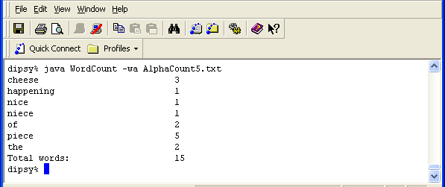

Figure 1: sorted by ascending frequency

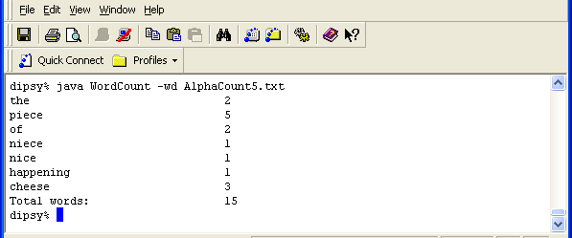

Figure 2: sorted by descending frequency

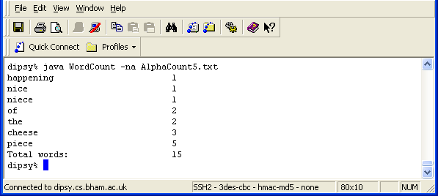

Figure 3: sorted by ascending alphabetical order

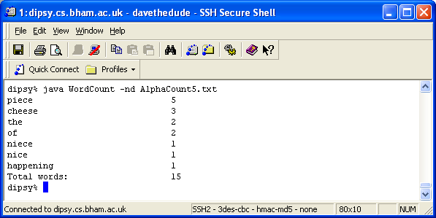

Figure 4: sorted by descending alphabetical order

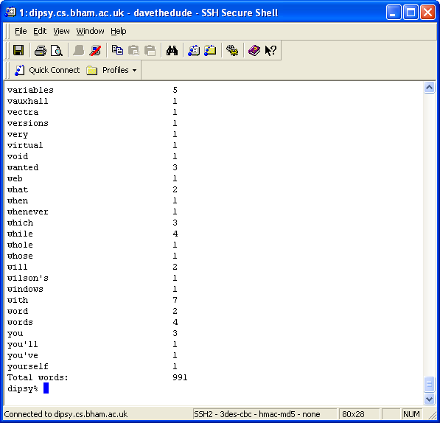

Figure 5: sorted by descending alphabetical order (default)

